**Date: -02-2022 Registration#__________________**

University of Engineering & Technology Lahore, FSD Campus

Experiment # 8

Title: Multirate Signal Processing

Equipment Required: Personal computer (PC) with windows operating system and MATLAB.

**Task 1**

Generate the following sequences:

$$x_{1}\left(n\right)=\sin\left(2πfn\right), f=0.1 Hz$$

$$x_{2}\left(n\right)=\sin\left(2πfn\right), f=0.3 Hz$$

$$x\left(n\right)= x_{1}\left(n\right)+x_{2}\left(n\right)$$

$$y\left(n\right)= x_{1}\left(n\right)*x_{2}\left(n\right)$$

Read the helping topics

* DOWNSAMPLE
* UPSAMPLE
* INTERP
* DECIMATE
* RESAMPLE

**Questions**

1. Perform the factor-of-4 down-sampling. Plot the original and down-sampled sequences.
2. Part (a) for the factor-of-5 up-sampler. Plot the original and up-sampled sequences.

**Task 2**

Consider the system below:

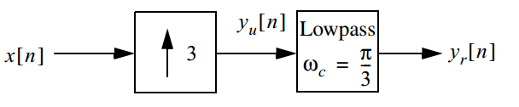

**Questions**

1. Read the documentation of MAT LAB's command firl. Design a lowpass FIR filter using the command.
2. Plot the frequency response of the lowpass FIR filter, $y_{u}[n]$ and output sequence.
3. Implement an equivalent polyphase decomposition based decimation system for the system above in MATLAB. How many additions and multiplications are required per unit time?
4. Do you see any gains in number of computations (i.e. without decimation and decimation)?